|  |
| --- |
| **National University of Computer and Emerging Sciences** |
| In Lab Exercise 7  “Triggers” |
|  |
| Database Systems |
| Spring 2018 |

Department of Computer Science

FAST-NU, Lahore, Pakistan

# Exercise

For this exercise use the following schema, the script to create this schema and populate data is given in Files HR_Schema_DDL AND HR_Schema_DML SQL files.

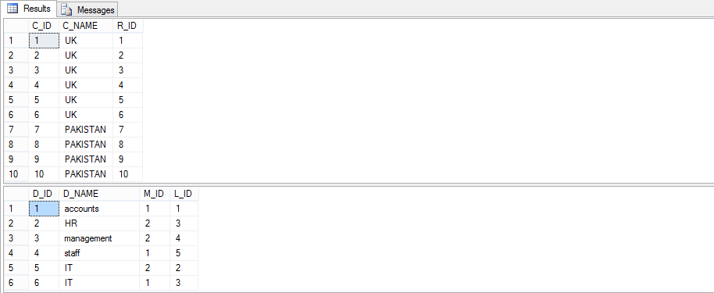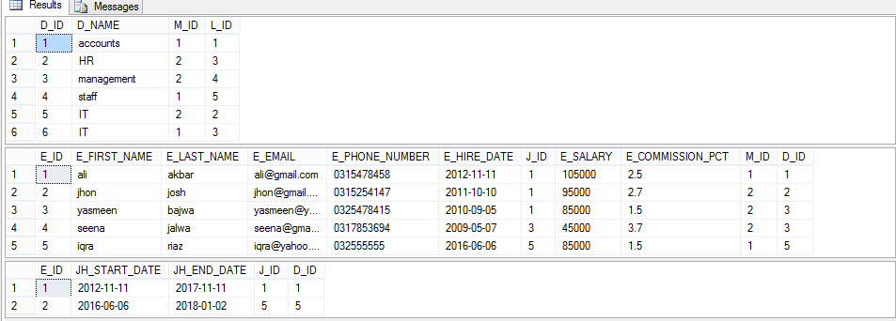

JOB_HISTORY Table

Employees Table

Department Table

Country Table

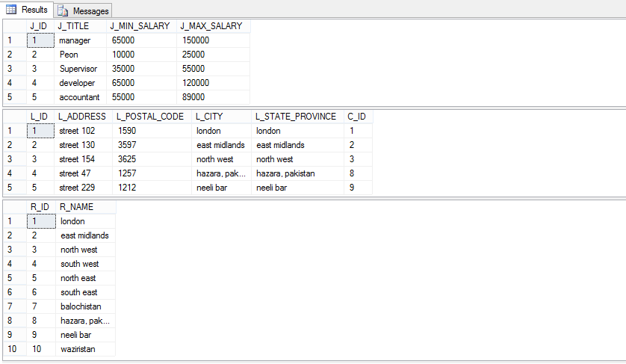

REGION Table

LOCATION Table

JOB Table

1. Create a trigger on Locations table whenever a location is deleted. Instead of deleting it shows a message that “You are not allowed to delete location”
2. Create a trigger on employees table, such that it should not allow experienced employees to be deleted. Experienced employees are the employees that have experience more than 5 years. (hint use DATE functions to calculate experience).
3. Create a trigger such that whenever you try to add employees, it ensures that the salary of the employee is in between the range that is given in the JOB table. If salary is in the range it allow to add employee else it print a message “Invalid Salary specified”.
4. Create a trigger that disallows dropping a stored procedure, instead print a message that ‘Procedures cannot be deleted’. Disable the trigger and see the effects. Then enable it.